**Exercise 1**

*Start up an instance on Amazon EC2 and get Apache web server running*

**Prior Knowledge**

Unix Command Line Shell

**Learning Objectives**

Understand about EC2 instances

Start an instance using the web interface

Configure the AWS command line

Manage instances from a command line

Understand Security Groups

**Software Requirements**

(see separate document for installation of these)

* AWS CLI

**Part A: Starting an Instance from the Web Console.**

1. You have been provided with an Ubuntu VM. Start that up. Please ask the TA or lecturer if you don’t know how to do that.
2. The course is also providing time and resources on the Amazon AWS/EC2 cloud for the duration of the course. Please don’t abuse this!
3. Although it is possible to do the following exercises on your normal “host” OS, please do not! Part of this exercise is to install a key and access key into the Ubuntu VM which is needed for later exercises, so please do this from the Ubuntu VM.
4. Open up a browser window and navigate to   
   [**https://ox-clo.signin.aws.amazon.com/console**](https://ox-clo.signin.aws.amazon.com/console) 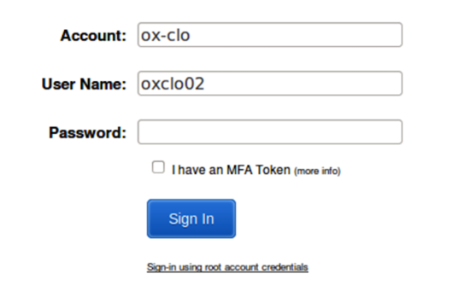Hint: make a bookmark for that URL
5. Use the userid and password **that you have been given**. You will need to create a new password:  
     
   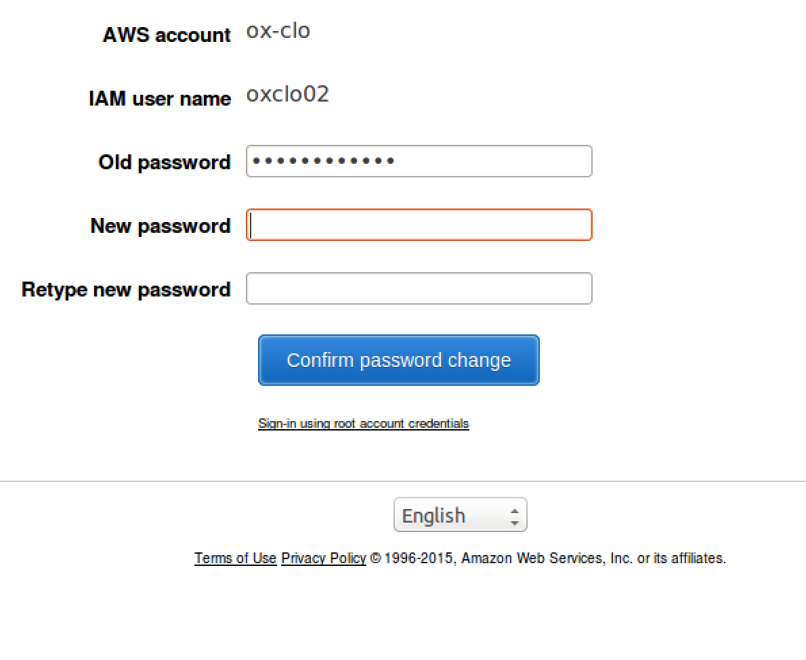
6. You should see a screen like this:  
   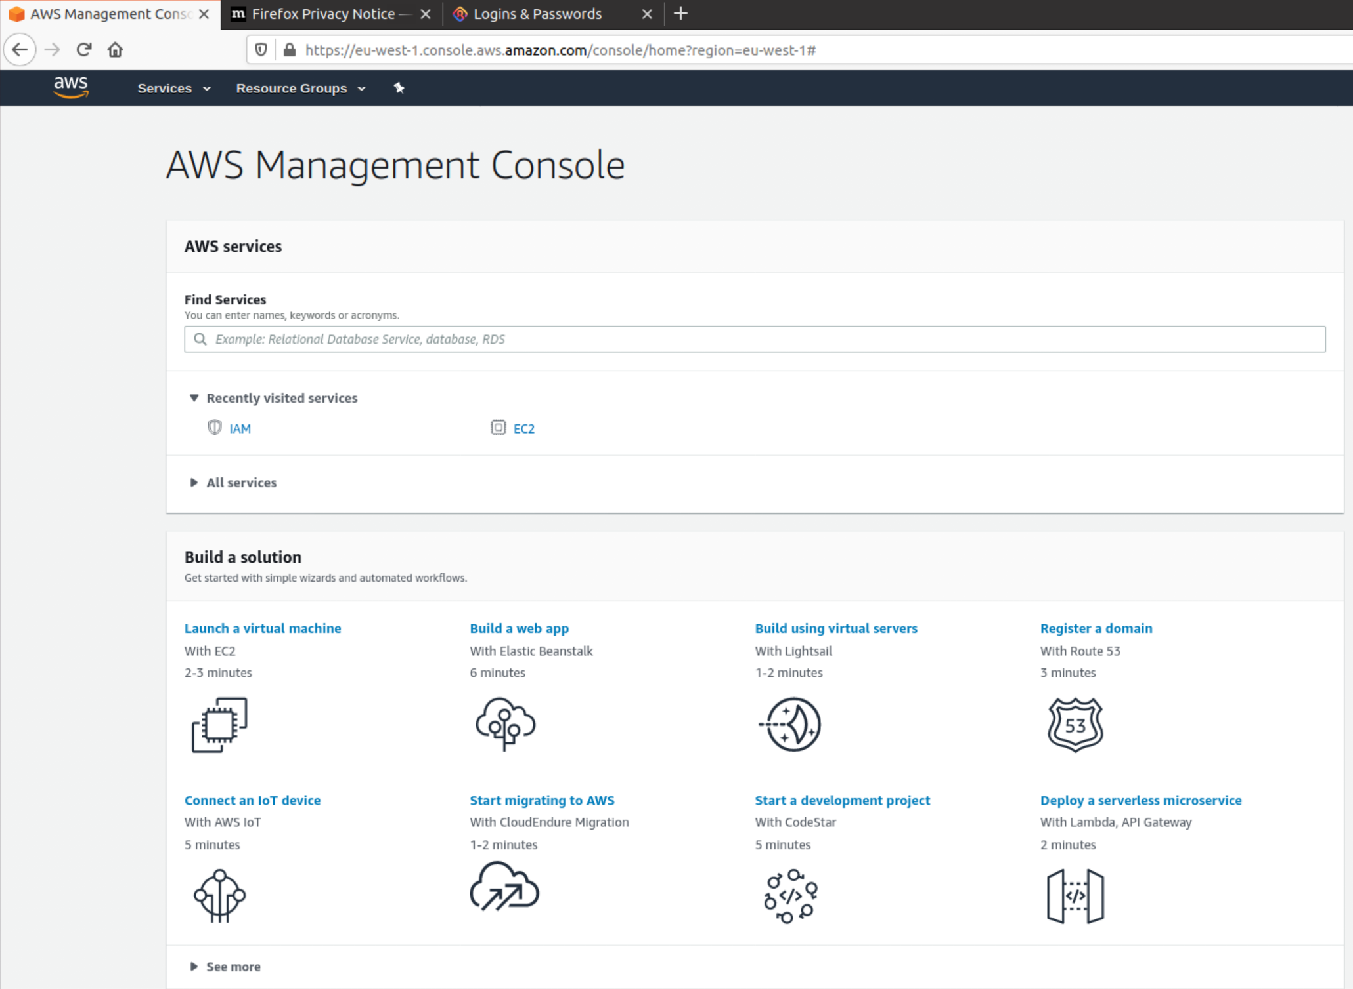
7. In the top right corner click on Oregon and change to **EU (Ireland) (unless it is already on Ireland!)**
8. Expand **All Services:**

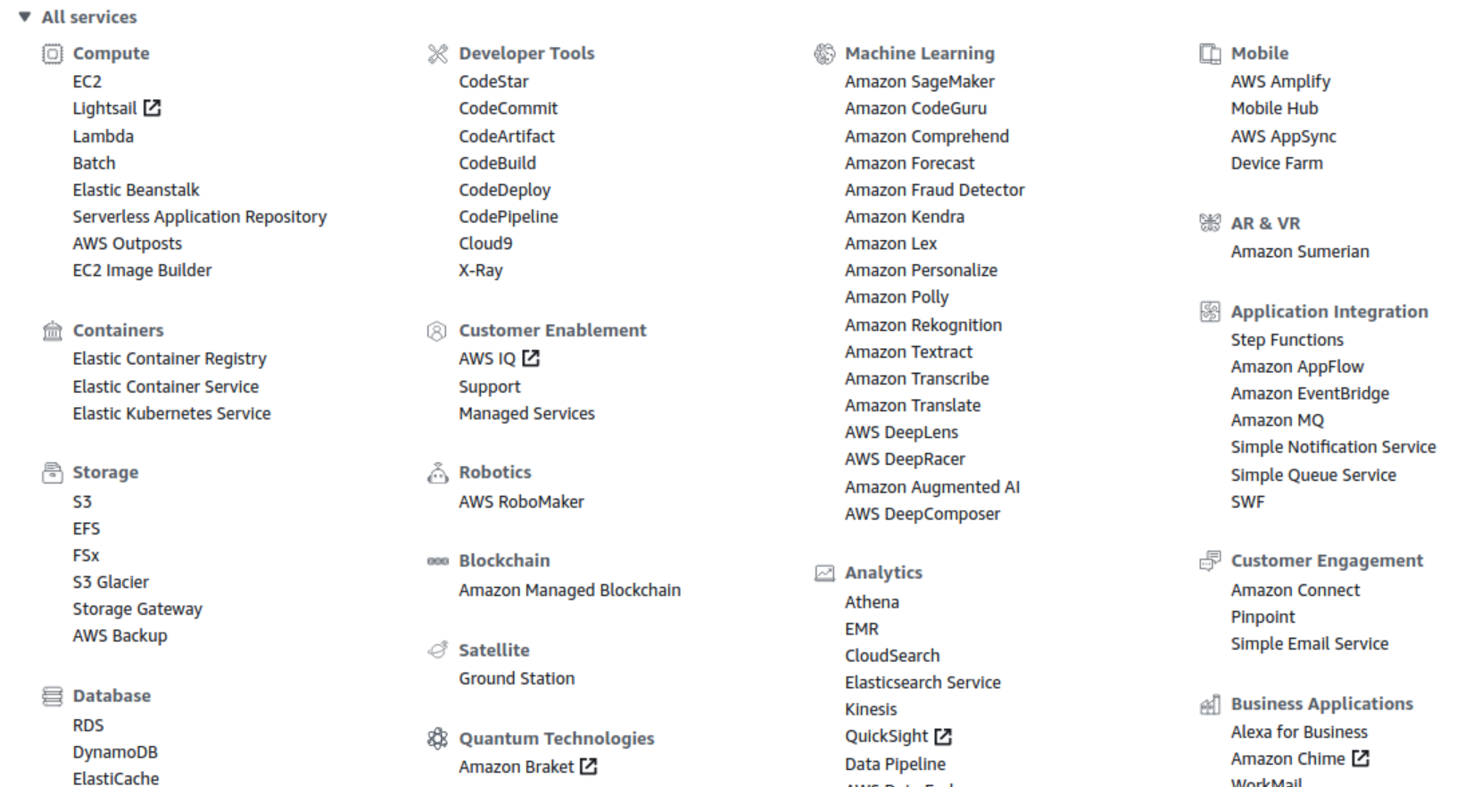

1. Now click on the link **EC2**  
   
2. Please note:
3. As a result, the screen below will differ depending on who has done different parts of this exercise.  
     
   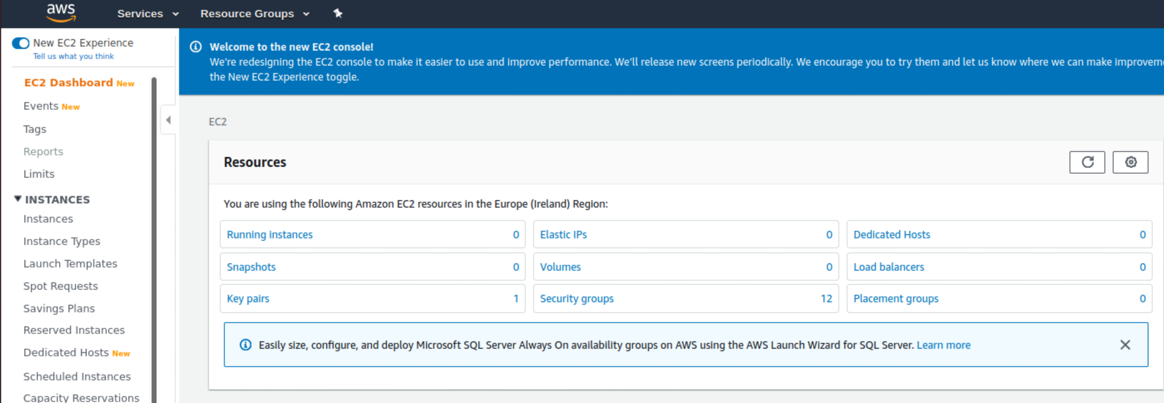
4. Click on the button: **Launch Instance**
5. Choose “**Ubuntu Server 18.04 LTS (HVM), SSD Volume Type**”

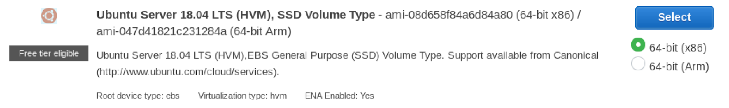

1. Choose the instance type **t2.micro**.
2. Click **Next: Configure Instance Details**
3. Click **Next: Add Storage**
4. Click **Next: Add Tags**
5. In the Tag Instance screen, give your instance a Name.

**Add a tag.**

Make the *Key*be **Name**  
Make the *Value* the same as your userid. 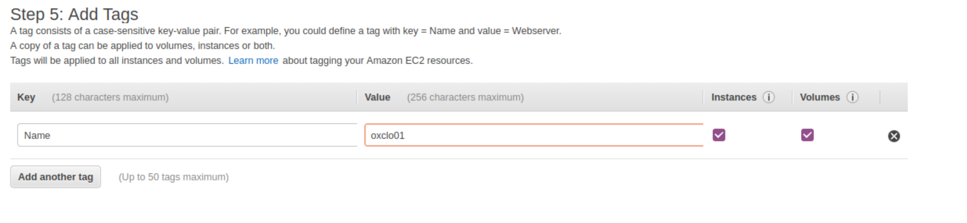

1. Now click: **Next: Configure Security Group**
2. Change the name of the security group to <your userid>-sg.  
   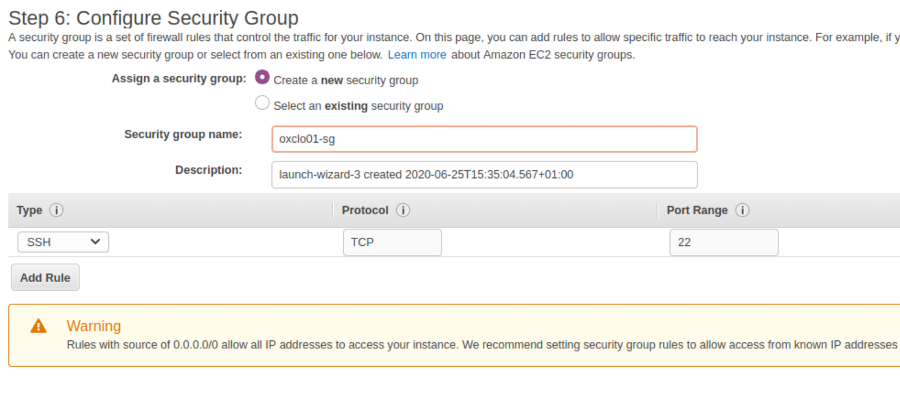
3. Click **Review and Launch**You should see something very like this:  
   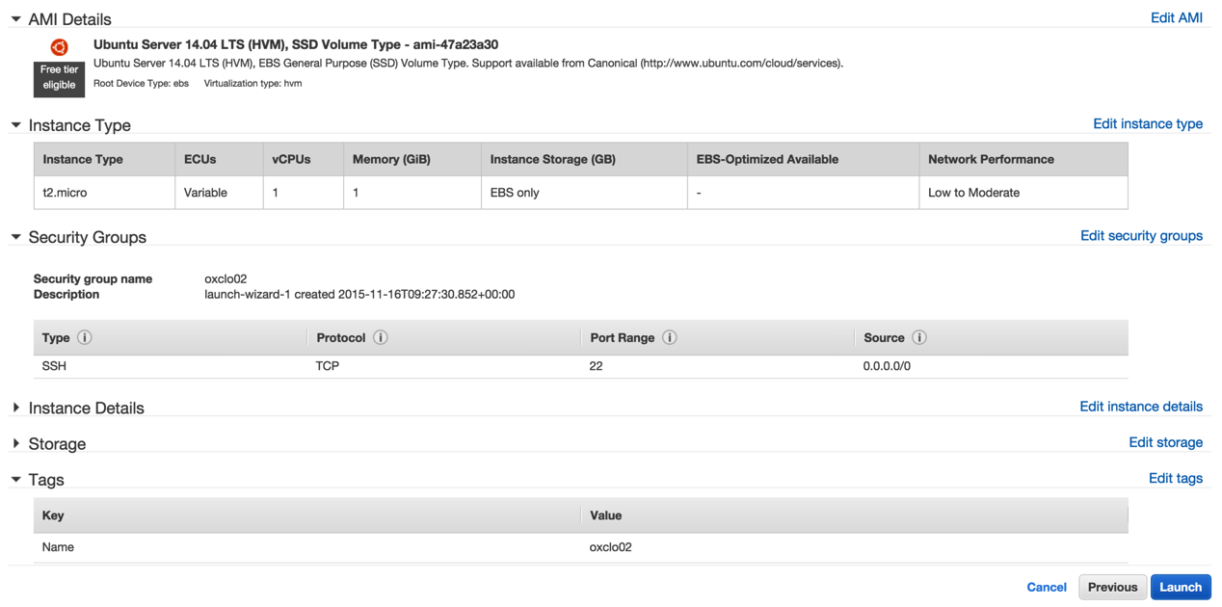
4. Click **Launch**
5. You will be prompted with a new window to decide on the correct key pair to secure this instance with. Since this is the first time you are using EC2, you need to create a key pair. Change the dropdown box to **Create a new key pair.**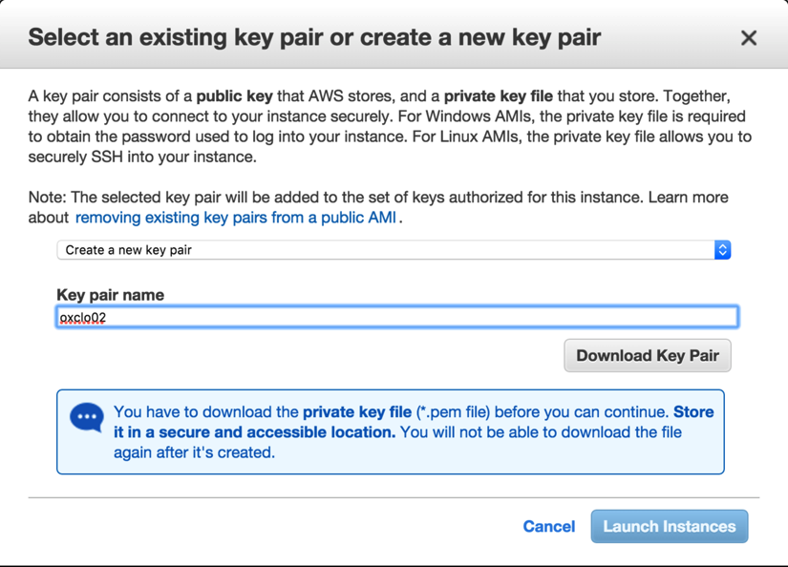
6. Change the name of the key pair to your userid.
7. Click **Download Key Pair**. This will save a file to your ~/Downloads directory.
8. Click **Launch Instances**You should see something like:  
   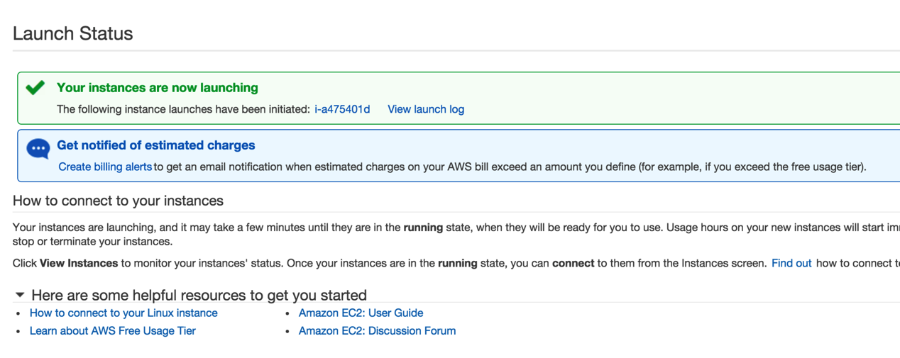
9. Click on the blue instance ID link (e.g. **i-a475401d**in the screenshot above)  
   You will see a dashboard like:  
   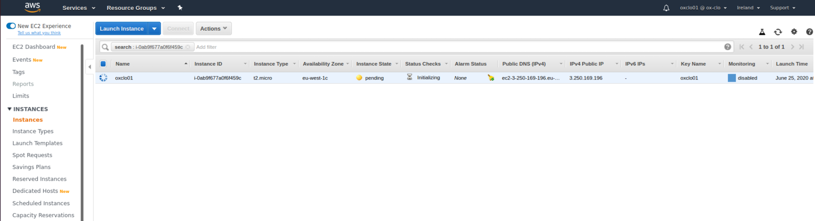
10. Make sure you are running the Ubuntu VM, and start a fresh terminal window (Ctrl-Alt-T, or find Terminal in the side bar)
11. Check is there is already a ~/keys directory.  
      
    **If not,** then make a directory to store your private key:  
    mkdir ~/keys
12. Copy your private key to the new directory:  
    cp ~/Downloads/oxclo**\*.**pem ~/keys/
13. Before you can use the key you need to change the permissions on it. Type:  
    chmod 400 ~/keys/oxclo*.pem
14. Check to see if the status checks on your instance are now complete. Refresh the browser window:  
    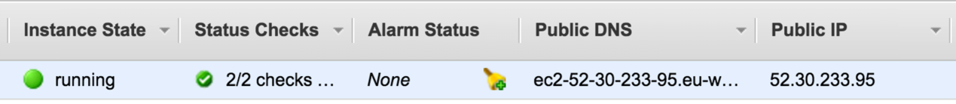
15. Copy the Public IP Address from the browser window (e.g. 52.30.233.95 in my case)
16. Try to SSH into the machine. Replace your key file name and the IP address below!  
      
    ssh –i ~/keys/oxclo**nn**.pem [ubuntu@**ww.xx.yy.zz**](mailto:ubuntu@ww.xx.yy.zz)
17. As this is the first time you are accessing this host, the key on the server side is not known. You should see something like:  
      
    The authenticity of host '52.30.233.95 (52.30.233.95)' can't be established.  
    ECDSA key fingerprint is SHA256:7GhOakN9Pj3vWAegV0uYhPVI9qqVEe9RlNM0wcutO1E.   
    Are you sure you want to continue connecting (yes/no)?

Type **yes** and hit Enter.

You will see something like:

1. **Congratulations** – you have a cloud instance running. **PART B – Running a Web Server**
2. In the SSH shell type:  
   sudo apt update  
     
   You will see a lot of log, e.g.:

Hit http://eu-west-1.ec2.archive.ubuntu.com trusty/universe Translation-en

Ign http://eu-west-1.ec2.archive.ubuntu.com trusty/main Translation-en_US

Ign http://eu-west-1.ec2.archive.ubuntu.com trusty/universe Translation-en_US

Fetched 10.3 MB in 3s (2,713 kB/s)

Reading package lists... Done

1. Now type:  
   sudo apt install apache2
2. You will see:  
   
3. Hit Enter (same as Y). The log should look like:  
   
4. Check locally if it is running:
   1. curl <http://localhost>
   2. You should see a lot of HTML scroll by.
5. Now try browsing the server from your local machine. Find the Public IP address or Public DNS name from the EC2 console and use that in a browser window.
6. It will timeout because we have not enabled port 80 (www) to be accessed. Go back to the EC2 dashboard, and choose **Security Groups** from the left hand menu.
7. Find the group that you created that uses your userid as the Group Name, select it, and then choose **Actions -> Edit Inbound rules**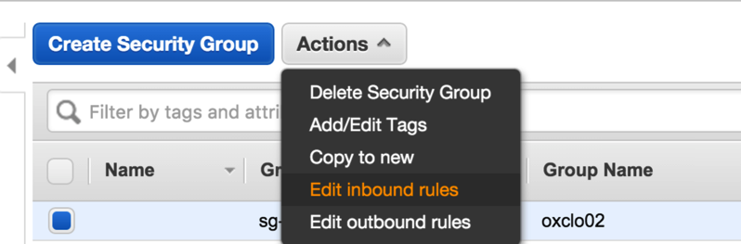
8. Click **Add Rule**
9. Click on the drop down box that says “Custom TCP Rule” and change it to **HTTP**.
10. Change the **Source** from Custom to **Anywhere**
11. Click **Save**.
12. Now try browsing to the webpage again. You should see:

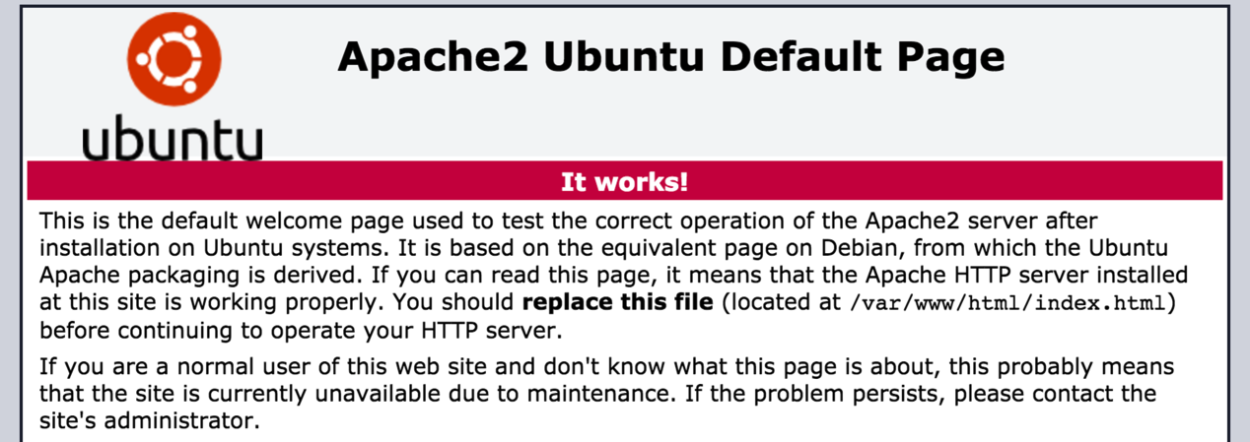

1. Congratulations!  
     
   **PART C – Using the AWS Command Line**
2. The AWS Command Line (AWS CLI) is available as part of the Python PIP installed code. PIP is a package manager for Python.
3. In a fresh Ubuntu Terminal Window (*make sure you are not doing this on your cloud server by mistake!)*
   1. Type:  
      sudo pip install awscli  
      you should see log ending like:



This is because it is already installed. Otherwise you will see:



1. Now you can configure the AWS command line with your credentials  
   1. First we need to create an Access Key and Secret Key for you. I could have printed one out for you, but that would be difficult to type in, so let’s go create one in the AWS Console.
   2. Go to the AWS Console
   3. In the top right corner, click on your username, then choose **My Security Credentials**:   
      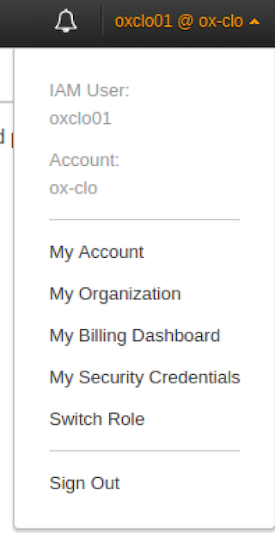
   4. You should see something like: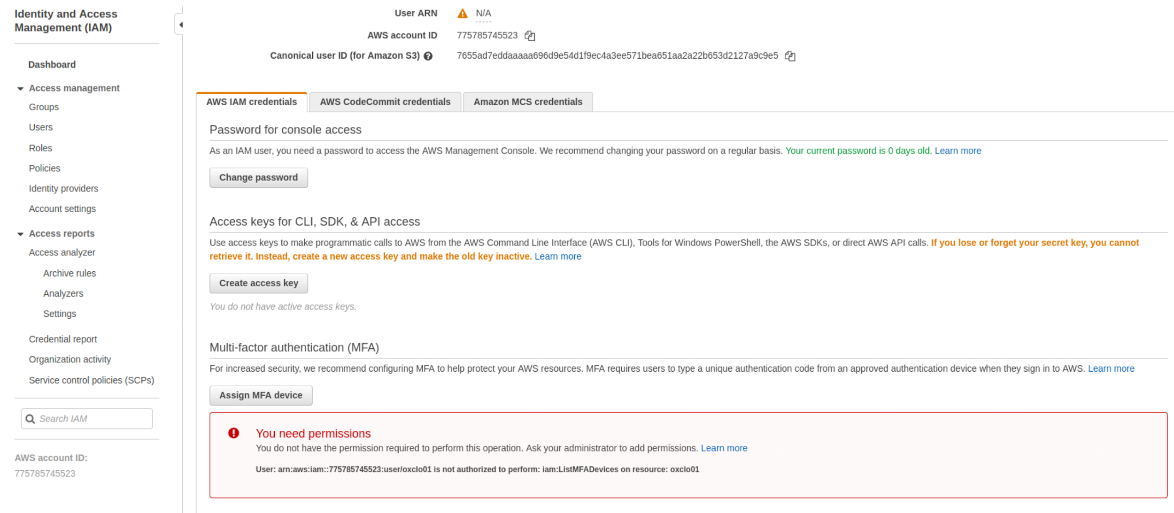

Click on **Create Access Key.**   
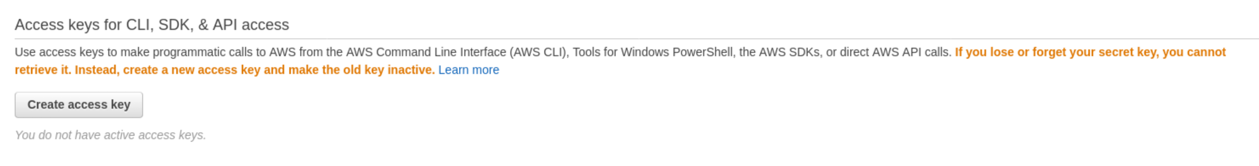

You should see

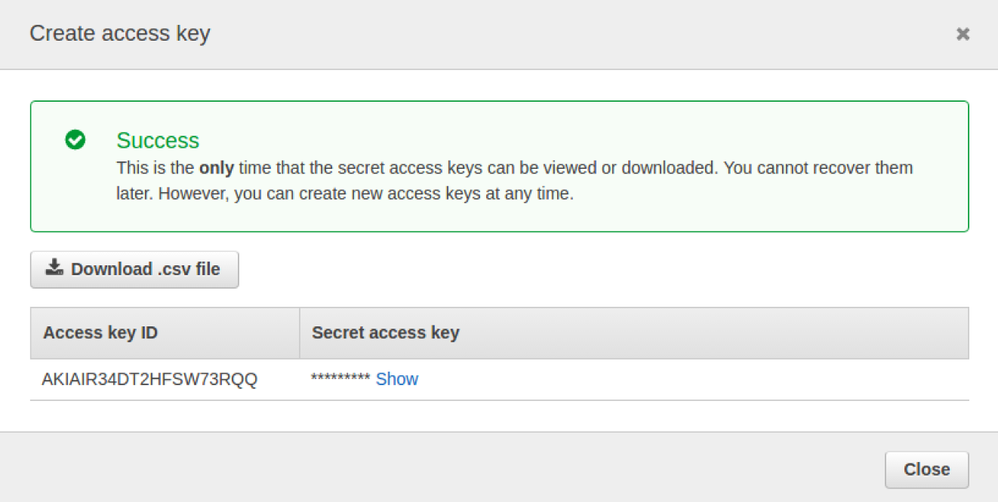

* 1. Click **Download .csv file** and then **Save**
  2. You can also click Show and then copy and paste these two token identifiers into a new text file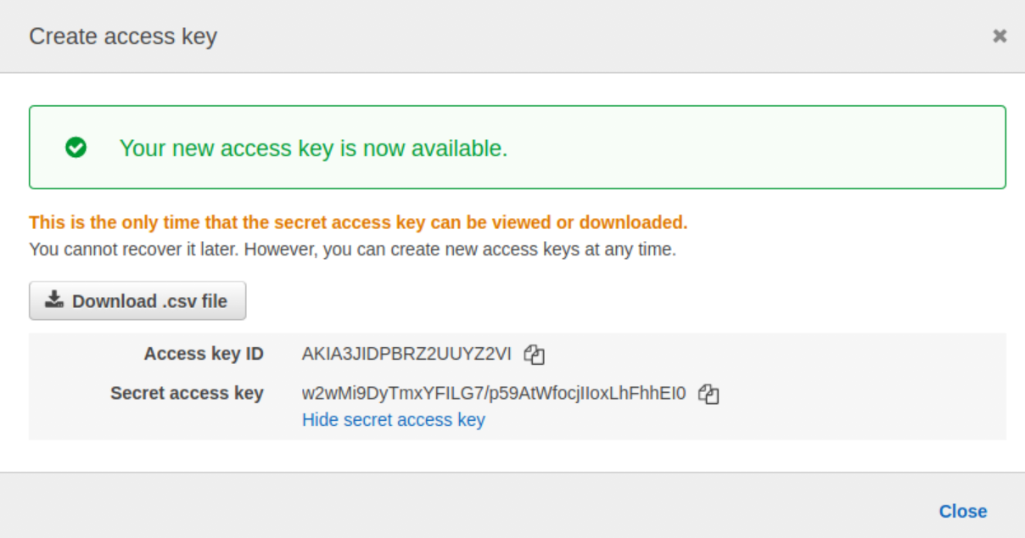

* 1. ***You need to make a note of these credentials or download them, because the secret key will not be available again.***

***t***

1. Now we can use these keys to configure the AWS CLI. Back in the terminal window where you installed the AWS CLI, type:  
     
   **aws configure**  
   1. When prompted  
      AWS Access Key ID [None]:  
        
      Type the Access Key ID from the text file or CSV (cut and paste)
   2. Do the same for the Secret Access Key.
   3. For the region choose Ireland: **eu-west-1**
   4. For the output format, type **json**



1. Now let’s use the CLI to terminate your instance.
2. From the console (we could get this from the CLI too, but its complex to describe) copy the instance id of your running instance.
3. Now use the AWS CLI to terminate:  
   Replacing the instance ID with your own, type:  
     
   aws ec2 terminate-instances --instance-ids **i-0b735618d9e69b35b**
4. You should see log like:  
   

Your SSH session to the server will die, and the web site will no longer be running.

1. Congratulations! You have completed all three parts of this Lab.